**Bearing Checker – 880Plus**

**5 Functions in one**

**Shock Pulse Function, Vibration Velocity, Acceleration, Displacement & Laser Tachometer Function**

**Features:**

**• Shock Pulse measurement**

(Mechanical & lubrication, damage development of bearing)

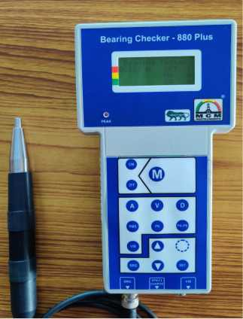

**• Mechanical Condition of bearings**

**• Lubrication condition of bearings**

**• Damage severity readings for rolling bearings**

**• Vibration Measurement all three parameters**

(Displacement, Acceleration & Velocity)

**• Laser Tachometer measurement**

**• Direct indication of machine condition**

**in terms of good–reduced-bad in bearing function**

**• Microprocessor based • Back light LC Display**

**• Auto Off • Battery Low Indication**

**Protective Maintenance:** To increase equipment availability with an effective machinery management program, it is important to apply the appropriate maintenance strategy for all plant equipment. A predictive maintenance program optimized for a typical plant environment has many rewards:

• **Eliminate unplanned equipment shutdowns**

• **Extends the period between scheduled overhauls**

• **Reduced spare parts inventory**

• **Improves product quality, and ensure that new and rebuilt equipment meets specifications.**

**MCM** Presents a small Micro Processor based diagnostic tool for comprehensive condition analysis of rotating machinery. Objective measurements of machine condition are needed as a reliable base for preventive maintenance. Now maintenance personal can **analyze bearing condition** (mechanical & lubrication) **/ detect machine vibration**, **and check rotational speed** - with a single and easy to use instrument. The best way is to periodically monitor machine condition for production efficiency.

**Technical Specifications**

|  |  |
| --- | --- |
| **• Shock Pulse Function: Measuring Range**: -19 to 99 dBpv | • Power: Lithium Ion rechargeable Battery 7.4V, 2500mAh |
| Resolution: 1 dBpv | • Display: 4 x 16 line back light dot matrix LCD |
| Bearing Condition: Green,Yellow and Red indication in LCD display | • Operating Temp. Range: 0 - 55ºC |
| •**Vibration Function: ISO 2372 / ISO 10816** | • Sealed Membrane key pad |
| **• Velocity**: 0.1 –199.9 mm/s True RMS, 282mm/s PK, 565 mm/s PK-PK | • Input Connectors: BNC,TNC & Round |
| **• Acceleration**: 0.1 – 199 m/s² RMS, 282 m/s² PK, 565 m/s² PK-PK | • Casing: ABS |
| **• Displacement**:1 –1000 µm RMS,1414 µm PK, 2800 µm Peak – Peak | • Size: 230x100x45 mm |
| Resolution: 0.1 mm/s | • Weight: 750gm. App.(Instrument) |
| Accuracy: ± 2% + 0.1 mm/s |  |
| Frequency response: 10 – 1khz |  |
| **• Laser Tachometer: Measuring Range**: up to 20,000 rpm |  |
| Resolution: 1 rpm |  |
| Accuracy: ± (1 rev. + 0.1% of reading) |  |

**Standard Supply**

➢ Bearing Checker – 880Plus

With protective cover

➢ Shock Pulse Probe - 1no

➢ Head Phone - 1no

➢ Vibration sensor - 1set (Magnetic base, Hand held probe rod, Cable with connectors)

➢ Laser Tachometer Probe - 1no

➢ Batter y Charger - 1 no

➢ Instrument Manual - 1no

➢ Test & Calibration Report with Warranty/Guarantee Certificate

➢ Carry Bag

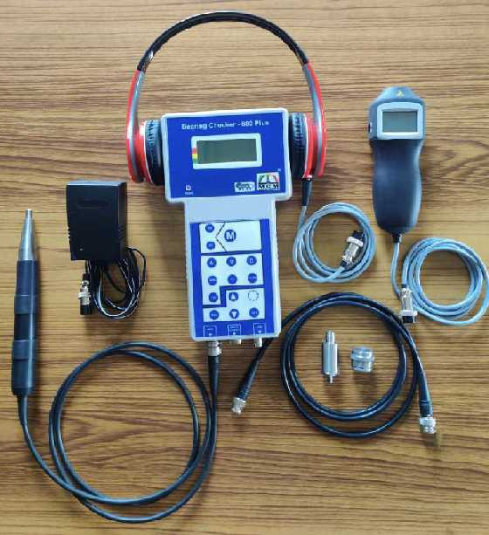

|  |  |
| --- | --- |
| https://pmequipments.com/assets/img/pm_equipments_logo.png | **PREDICTIVE MEASURING EQUIPMENTS**  Plot No 146, Phase 1, Mytrinagar, Madinaguda, Hyderabad – 500049  Mobile: +91-90593 40351, eMail: info@pmequipments.com, www.pmequipments.com |

Technical data are subject to change without notice